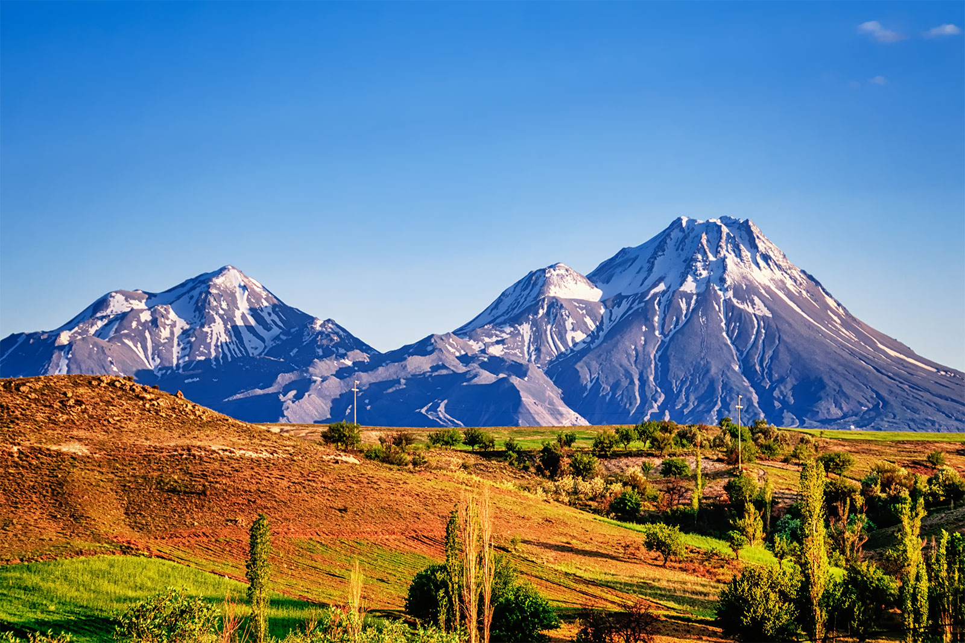 Year 4 – Swans 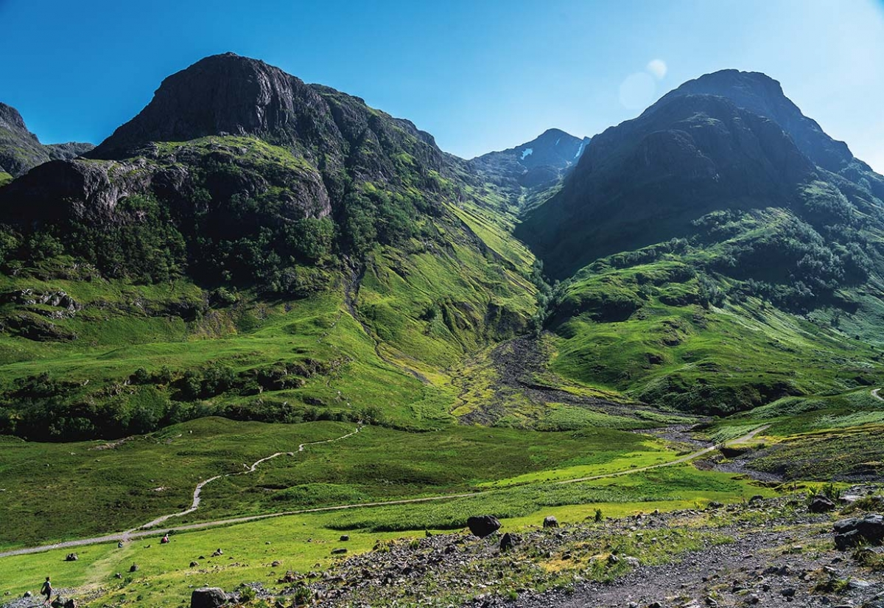

We hope that you have had a lovely half term break and are ready for an exciting new term! Our topic this half term is called ‘Misty Mountain Sierra’ – and we’re going up in the world, finding out about hills, upland areas and moors, and noticing how the weather changes.

Our Topic this term has a geography focus, thinking about maps and human geography.

As well as our main topic we will also cover these areas:
- In English we will be looking at recounts and non-chronological reports, calligrams, explanations, narratives and leaflets.
- In music we will be inventing an accompaniment, composing a melody and recording and appraising a composition.
- In PE we will be playing tennis and exploring the Haka (dance).
- In computing we will be writing for different audiences.
- In PSCHE our focus is ‘healthy me’.
- In Art/DT we will be creating 3D mountains as well as sketching and using simple collage.

In Maths we will be following the National Curriculum with a focus on Fractions and Decimals.

Maths or English homework will usually go out on a Friday and be returned the following Thursday. Our main maths focus for homework is learning our times tables and developing our speed and accuracy.

You could help your child prepare for their project by climbing a mountain – it’s an exciting adventure!
For their homework the children will be researching mountains, the animals that live there or sports that can be enjoyed there! Why not do it together? (Well…not too much help!) Alternatively, visit the library together to find out how mountains are formed and where in the world they can be seen.

Please feel free to pop in to ‘Drop In’ every other Wednesday at 3pm. We are always happy to discuss matters that are important to both you and your child.

Mrs Criddle

